**Central Tendency Assignment**

* The dataset is based on “Placement” of MBA Student dataset.
* Based on the dataset can able to analyze about the students and salary of the student placed.

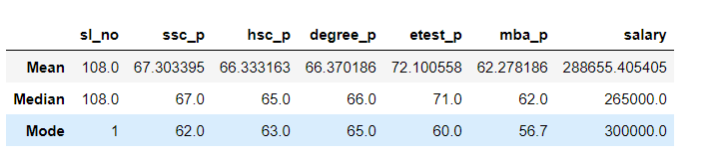

* The above screenshot shows the student average SSC, HSC, Degree, Entrance, MBA Pass score and salary of the student.
* In this class in SSC, HSC, Degree the students are below average.
* In entrance test they performed well and they got Good Performance.
* In MBA again, the average got dipped and moved back to below Average.
* Maximum student in SSC got 62 mark, HSC – 63, DEGREE -65, entrance – 60 and in MBA – 56.7.
* So, the average salary of these kind of student is comes under 2,65,000.
* In that maximum student got 300000.